Exp 20: VirtualBox — Change Hardware Compatibility of an Existing VM (by clone/create-new)
Aim
Modify a VirtualBox VM’s virtual hardware (chipset, firmware, controllers, graphics) by cloning or creating a new VM and attaching the existing disk.
Procedure
- Power off the source VM → File → Clone → choose Full clone (or create New VM).
- In the cloned/new VM Settings → System → Motherboard, change Chipset (e.g., PIIX3 ↔ ICH9) and toggle Enable EFI if needed.
- System → Acceleration: set Paravirtualization Interface (Default/Hyper-V/KVM) and ensure VT-x/AMD-V & Nested Paging are enabled if supported.
- Display → Graphics Controller: pick VMSVGA (Linux), VBoxSVGA (Windows 10/11), or VBoxVGA for legacy needs; adjust VRAM.
- Storage: switch disk Controller type (SATA/SCSI/NVMe) as required; if you created a new VM, Attach existing VDI/VMDK from the old VM.
- Start the VM → install/upgrade Guest Additions if prompted → verify devices in guest OS (Device Manager/Lspci).
Output

Figure 1 Virtual Machine with 1 CPU, 2 GB RAM, and 15 GB storage
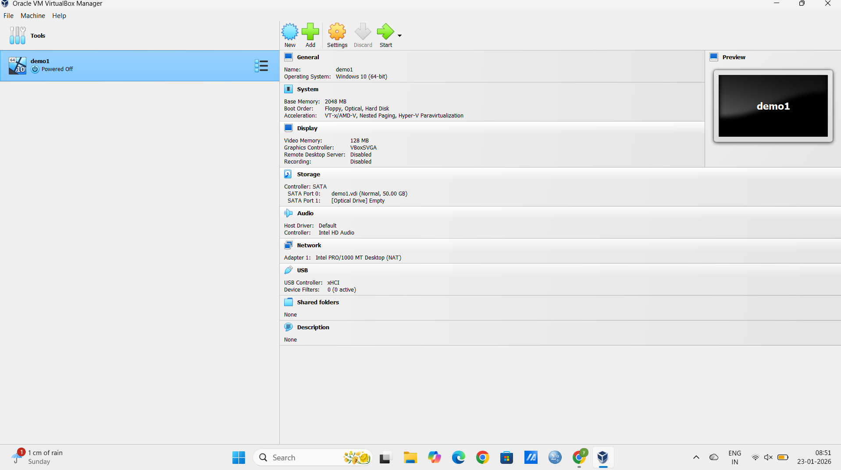
Result
A bootable VM with updated virtual hardware profile; guest OS recognizes the new chipset/graphics/controller and runs normally.

